Practical 3: State Management and Routing in React

Objective | To consume a REST API in React and handle asynchronous data with  loading and error states.
Problem Statement | Integrate a public REST API (e.g., GitHub API) into the portfolio  application to fetch and display a list of repositories dynamically.  • Use the Projects page built in Practical 2 as the integration point.  • Implement a loading spinner component shown while the request is in  progress.  • Implement an error message component shown if the API call fails.  • Render at least the repository name and URL for each item returned.
Project Structure | Projects.jsx  ├── useEffect() → triggers fetch on mount  ├── useState: data, loading, error  ├── [loading] → <Spinner />;  ├── [error] → <ErrorMessage />;  └── [success] → <RepoList data={data} />;
Implementation | Project.jsx  import { useState, useEffect, useCallback } from 'react'  // You can change your GitHub username here to show your own repositories  const GITHUB_USERNAME = 'Vaghasiya-Jemit-kanaiyalal'  function Spinner() {  return (  <div className="spinner-container">  <div className="loading-spinner"></div>  <p>Fetching repositories from GitHub...</p>  </div>  )  }  function ErrorMessage({ message, onRetry }) {  return (  <div className="repo-error-message">  <p>⚠️ Error: {message}</p>  <button onClick={onRetry} className="retry-btn">  Retry  </button>  </div>  )  }  function RepoList({ data }) {  return (  <div className="projects-grid">  {data.map((repo) => (  <div key={repo.id} className="project-card">  <div className="project-header">  <h3>  <a  href={repo.html_url}  target="_blank"  rel="noopener noreferrer"  className="project-title-link"  >  {repo.name.replace(/-/g, ' ').replace(/_/g, ' ')}  </a>  </h3>  </div>  <p className="project-desc">  {repo.description || 'No description provided for this repository.'}  </p>  <div className="project-meta">  {repo.language && (  <span className="tech-badge language-badge">{repo.language}</span>  )}  <div className="repo-stats">  <span title="Stars">⭐ {repo.stargazers_count}</span>  <span title="Forks">🍴 {repo.forks_count}</span>  </div>  </div>  <div className="project-footer">  <a  href={repo.html_url}  target="_blank"  rel="noopener noreferrer"  className="view-repo-btn"  >  View on GitHub  </a>  </div>  </div>  ))}  </div>  )  }  function Projects() {  const [data, setData] = useState([])  const [loading, setLoading] = useState(true)  const [error, setError] = useState(null)  const [searchQuery, setSearchQuery] = useState('')  const fetchRepos = useCallback(async () => {  try {  setLoading(true)  setError(null)  const response = await fetch(  `https://api.github.com/users/${GITHUB_USERNAME}/repos?sort=updated&per_page=100`  )  if (!response.ok) {  if (response.status === 404) {  throw new Error(`GitHub user "${GITHUB_USERNAME}" not found.`)  } else if (response.status === 403) {  throw new Error('API rate limit exceeded. Please try again later.')  } else {  throw new Error(`Failed to fetch repositories (Status ${response.status}).`)  }  }  const repos = await response.json()  setData(repos)  } catch (err) {  setError(err.message || 'An error occurred while fetching repositories.')  } finally {  setLoading(false)  }  }, [])  useEffect(() => {  fetchRepos()  }, [fetchRepos])  const filteredData = data.filter((repo) => {  const query = searchQuery.toLowerCase()  const nameMatch = repo.name?.toLowerCase().includes(query)  const descMatch = repo.description?.toLowerCase().includes(query)  const langMatch = repo.language?.toLowerCase().includes(query)  return nameMatch || descMatch || langMatch  })  return (  <div className="projects-container">  <h2>My Projects</h2>  <div className="search-container">  <input  type="text"  placeholder="Search repositories by name, description, or language..."  value={searchQuery}  onChange={(e) => setSearchQuery(e.target.value)}  className="search-input"  />  {searchQuery && (  <button  onClick={() => setSearchQuery('')}  className="search-clear-btn"  title="Clear search"  >  &times;  </button>  )}  </div>  {loading && <Spinner />}  {!loading && error && <ErrorMessage message={error} onRetry={fetchRepos} />}  {!loading && !error && <RepoList data={filteredData} />}  {!loading && !error && filteredData.length === 0 && (  <div className="no-repos-found">  <p>No repositories found matching "{searchQuery}".</p>  </div>  )}  </div>  )  }  export default Projects
Output | 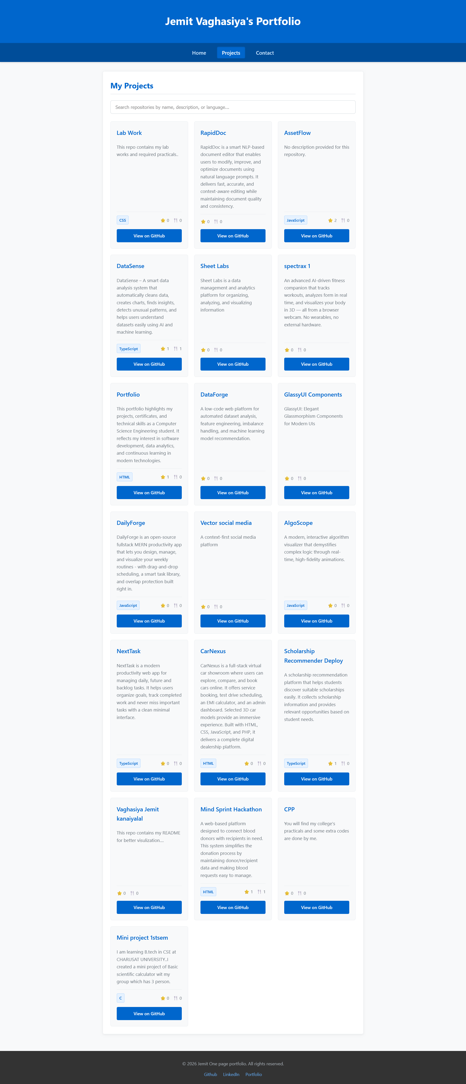
Conclusion | In this practical, I connected a public REST API to the React project and displayed GitHub repositories. I also showed a loading spinner while data was loading and an error message if something went wrong. This helped us learn how to fetch and display data from an API in React.

